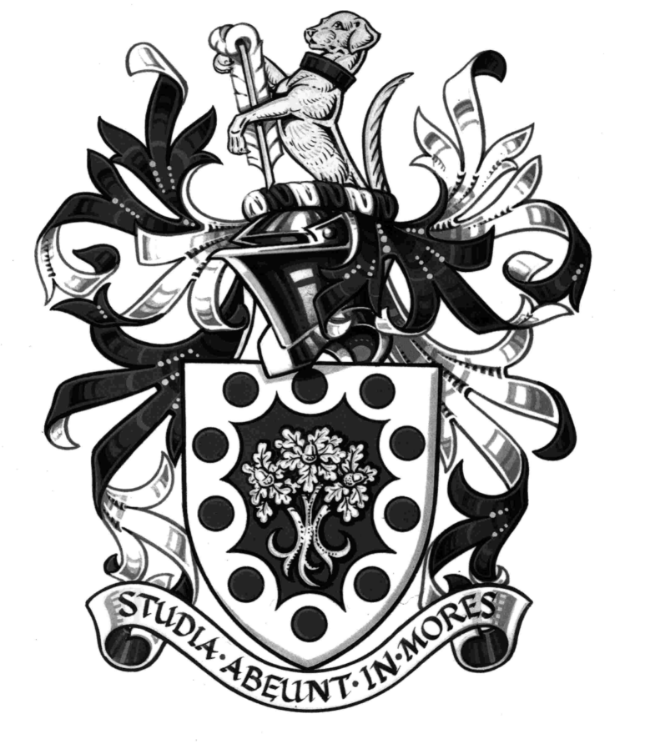

Hurtwood House Performing Arts Scholarships

Hurtwood House is offering a limited number of two-year A-level Performing Arts scholarships in this year, one at 50% off the fees, two at 25% off the fees and three at 10% off the fees. The major scholarships are awarded to students auditioning in all three of the disciplines - acting, singing and dance.

Clearly, we are not expecting students of this age to have received a great deal of formal vocational training, but we are looking for evidence of outstanding talent and natural skills. We are looking for young people with enthusiasm and commitment who would make a positive contribution to the Hurtwood Theatre during their time here.

Scholarships are awarded for the full two-year period of the student's A-levels, but will be subject to review at the end of the first year. Successful candidates will be expected to take A-level Theatre Studies as part of their A-level programme, and to contribute to all major school productions.

Before auditioning for one of these scholarships, it is necessary for students to come for an interview, so if you decide you would like to apply for a scholarship and have not already visited the school you should contact the school secretary to arrange an appointment. Once you have had your interview, you may complete the scholarship application form and return it to us so that we can enter your name onto the list of candidates for the next audition. Please note that a reference from your present school will also be required, and this will be written for on receipt of your completed application form.

Cosmo Jackson
Headmaster

HURTWOOD THEATRE
Performing Arts Scholarships

Closer to the audition you will be sent a schedule letting you know what time you should arrive at the school.

We would like to make this process an exciting and stimulating one. We want to see how you work creatively with others, as well as more formally as a performer, so we have put aside a day when you can meet our staff, work with us and get a flavour of the Performing Arts at Hurtwood.

What we would like you to show us:

ACTING.
You will present your work to us on your own in our Theatre Studio space. We would like you to perform
a piece by Shakespeare as outlined below. After you have performed the piece we will direct you to see whether you can explore other ways of doing it.

The Shakespeare extract: (One from the list below)
For girls:

Henry VI Part 1 (Act 5, Scene 4)
Joan La Pucelle: “First, let me tell you…………vengeance at the gates of heaven.”

All’s Well That Ends Well (Act 1 Scene 1)
Helena: “Oh, were that all!.............thus plagues itself.”

Troilus and Cressida (Act 3 Scene 2)
Cressida: “Hard to seem won………of speaking first.”

The Merchant of Venice (Act 3, Scene 2)
Portia: “I pray you tarry; pause a day or two………..And so all yours.”

For boys:

Richard III (Act 1 Scene 2)
Gloucester: “Was ever woman in this humour……..all the world to nothing! Ha!”

King Lear (Act 1, Scene 2)
Edmund: “Thou, Nature, art my goddess;…………Now gods, stand up for bastards!”

Othello (Act 3 Scene 3)
Iago: “I do not like the office……let us hide our loves.”

Coriolanus (Act 4 Scene 5)
Coriolanus: “My name is Caius Marcus…….whooped out of Rome.”

SINGING.
You should learn and prepare two contrasting songs of your own choice – one a ballad, the other with a strong rhythmic emphasis. An accompanist will be provided but you must provide the sheet music for both songs, fully written out for piano accompaniment and in the key in which you wish to sing. (The pianist will not transpose at sight.)

Important note: Do not choreograph your songs extensively. The panel are looking for your ability to make an emotional connection in acting terms and to tell the story of the song simply and to dramatic effect.

DANCE.
There is no need to choreograph a special piece as you will take part in a short class that explores a variety of dance styles and techniques. Be prepared to work barefoot! You may bring along soft ballet shoes/jazz shoes if you wish. Please ensure that you wear sensible/dance clothes.

APPLICATION FOR HURTWOOD PERFORMING ARTS SCHOLARSHIP

Name: ………………………………………………………………………………………………………………

Age: …………………………………………………. Sex: ……………………………………………..……….

Name and address of parents: ……………………………………………………………………………….

……………………………………………………………………………………………………………………….

……………………………………………………………………………………………………………………….

Telephone number (home): ……………………………………………………………………………………

Mobile number: ………………………………………………………………………………………………….

Parent e-mail: ……………………………………………………………………………………………………

Student e-mail: ………………………………………………………………………………………………….

Date of interview: ……………………………………………………………………………………………….

Name of present Headmaster/Headmistress: …………………………………………………………….

Present school: …………………………………………………………………………………………………..

E-mail of present school: ………………………………………………………………………………………

Discipline/s to be auditioned (please delete as appropriate): Acting/Singing/Dance

Stage experience (list on reverse if necessary):

……………………………………………………………………………………………………………………….

……………………………………………………………………………………………………………………….

……………………………………………………………………………………………………………………….

Musical training:

……………………………………………………………………………………………………………………….

……………………………………………………………………………………………………………………….

……………………………………………………………………………………………………………………….

Singing ability:

……………………………………………………………………………………………………………………….

……………………………………………………………………………………………………………………….

……………………………………………………………………………………………………………………….

Dance training:

……………………………………………………………………………………………………………………….

……………………………………………………………………………………………………………………….

……………………………………………………………………………………………………………………….

