Catering Assistant Full Time Monday - Friday 7.30am to 3.00pm
Catering Assistant Part Time Monday - Thursday 3.00pm to 7.30pm

Fixed Term Contract – 3 months which could become permanent
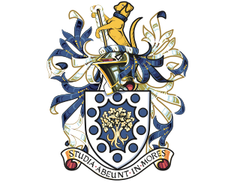
- Exclusive Boarding School Located in The Surrey Hills
Pay Rate £9.50 per hour.
Hurtwood House School
Holmbury St Mary, Dorking, Surrey RH5 6NU
We are looking for Catering Assistants for a wonderful family run private boarding school nestled in the Surrey Hills. We are looking for talented people to join our team producing and serving freshly prepared meals for 350 boarders using top quality locally sourced products. We have a modern well-equipped kitchen and even have a full size outside wood burning pizza oven!
The position will assist with the preparation of our fresh food offer and with serving customers, as well as with washing up and cleaning.
The ideal candidate will have previous experience working in a busy catering environment and be able to work as part of a team. You will be rewarded with a competitive salary.
Ideally you will have a background in an independent school, restaurant or an up-market contract catering site and will be looking for an exciting new challenge.
We are committed to safeguarding and promoting the welfare of children, all successful applicants will be required to complete an enhanced DBS application, provide two references and have the right to work in the UK.

Key information:
Catering Assistant Full Time Monday - Friday 7.30am to 3.00pm
Catering Assistant Part Time Monday - Thursday 3.00pm to 7.30pm
Sector: School Education
- Location: Near Dorking, Surrey
This vacancy is being managed by Mel Burley, Senior Consultant ISCC on behalf of Hurtwood House School.
Please state which vacancy you are interested in, complete the application form, scan and email to Mel.Burley@ISCC.co.uk.

